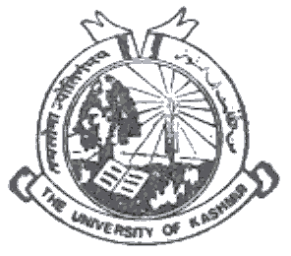 | Department of Earth Sciences  University of Kashmir, Hazratbal, Srinagar- I90006, J & K

Dr. Ghulam Jeelani  Professor & Head | NO: F96 (Research-ES) KU/21  Dated: September 16, 2021

NOTICE

It is notified for the information that the DRC meeting will be held on 20.09.2021 at 2:30 PM for the counseling of the candidates who are eligible for Integrated Ph.D. programme in Applied Geology under JRF/NET/SET/GATE exemption category. The candidates are directed to present themselves with all the necessary documents before the DRC members, failing which they will forfeit their claim for admission to IPhD.

Sd/-
Prof. Gh. Jeelani
Head of the department

Copy to:
- Dean Research, University of Kashmir for information please;
- Dean, School of Earth & Environmental Sciences for information please;
- Prof. M.A.Malik ( DRC Observer), Deptt. Of Physics for information please;
- Faculty members;
- file

